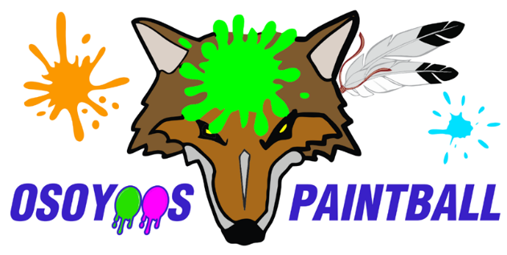

WAIVER AND RELEASE OF LIABILITY FORM

RELEASE OF LIABIILITY, WAIVE OF CLAIMS,
ASSUMPTION OF RISK AND INDEMNITY AGREEMENT

BY SIGNING THIS DOCUMENT, YOU WILL WAIVE CERTAIN LEGAL RIGHTS,
INCLUDING THE RIGHT TO SUE

To: Osoyoos Paintball LP

Assumption of Risk:

- I, the undersigned, wish to play Paintball, I recognize and understand that playing Paintball (hereinafter called the “Game”) involves certain risks. Those risks include, but are not limited to, the risk of injury resulting from possible malfunction of the equipment used in the game and injuries from tripping or falling over obstacles in the game playing field. In addition, I recognize that the exertion of playing the game could result in injury or death.

- Despite these and other risks, and fully understanding such risks, I wish to play the Game and hereby assume the risks of playing the Game. I also hereby hold harmless the “Sponsors” and indemnify them against any or all claims, actions, suits, procedures, costs, expenses (including attorney’s fees and expenses), damages and liabilities arising out of, connected with, or resulting from my playing the Game, including without limitation, those resulting from the manufacture, selection, delivery, possession, use or operation of such equipment. I hereby release the Sponsors from any and all such liability, and I understand that this release shall be binding upon my estate, my heirs, my representatives and assigns. I hereby certify to the Sponsors that I am in good health and do not suffer from a heart condition or other ailment which could be exacerbated by the exertion involved in playing the Game, I further certify that I am 18 years of age or older.
(Initials)
RELEASE OF LIABILITY, WAIVER OF CLAIMS AND INDEMNITY AGREEMENT

In consideration of participating in the “Game”, I hereby agree as follows:

- TO WAVE ANY AND ALL CLAIMS that I have or may in the future have against Osoyoos Paintball LP, their directors, officers, employees, agents and representatives (all of whom are hereinafter collectively referred to as “the Releasees”);
- TO RELEASE THE RELEASEES from any and all liability for any loss, damage, injury or expense that I may suffer or that my next of kin may suffer as a result of my participation in Paintball due to any cause whatsoever, INCLUDING NEGLIGENCE ON THE PART OF THE RELEASEES;
- TO HOLD HARMLESS AND INDEMNIFY THE RELEASEES from any and all liability for any damage to property of, or personal injury to, any third party, resulting from my participation in Paintball; and
- That this Agreement shall be effective and binding upon my heirs, next of kin, executors, administrators and assigns, in the event of my death.

I HAVE READ AND UNDERSTOOD THIS AGREEMENT, AND I AM AWARE THAT BY SIGNING THIS AGREEMENT I AM WAIVING CERTAIN LEGAL RIGHTS WHICH I OR MY HEIRS, NEXT OF KIN, EXECUTORS, ADMINISTRATORS AND ASSIGNS MAY HAVE AGAINST THE RELEASEES.

Signed this _________________ day of _______________, 202 .

_________________________________ __________________________________________________
Witness Signature of adult applicant 19 years of age and old

__________________________________________________
(Please print name clearly)

__________________________________________________
Signature of Parent if Participant is less than 19 years old

__________________________________________________
Print Name

PLEASE READ CAREFULLY!

